4
Graham Lister

4
Training Toolkit 4: Advocacy at Parliament

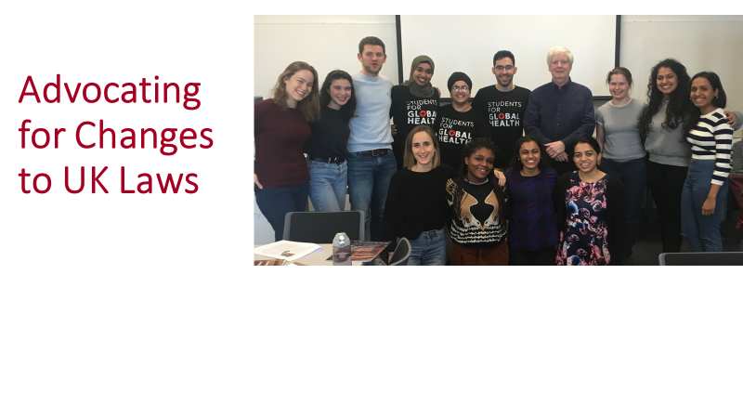
This training toolkit provides an introduction to the ways in which SfGH can take action to influence UK laws and their application at national and global levels. It is provided as a starting point for trainers to pass on the lessons and add their own experiences of success and failure. It has been developed at the request of the National Committee as an introduction to the basics of UK laws, and how parliament and other bodies develop policy, pass and interpret legislation. This indicates the points at which SfGH advocacy/lobbying can best influence decisions affecting global and local health, by presenting evidence and petitions, getting in touch with MPs, working with other groups and other means.
The issues covered include:
- Understanding UK laws and how they affect global and national human rights
- How laws are created: the Policy Process
- How to write Policy Documents
- How laws are created: the Parliamentary Process
- How laws are created: the Wellbeing of Future Generations Bill
- How Parliament works: Committees, APPGs and Inquiries
- How to contact your MP
- How to organise a Westminster ePetition
This toolkit does not deal with aspects of advocacy such as public engagement, digital communications, selecting topics ripe for action and working with allies which are covered in Toolkit 3 nor does it cover, advocacy at international meetings, and negotiating for change, which are the subject of Toolkit 5.
This toolkit provides suggestions for Trainers (in bold) you may chose to use the Powerpoints which are available at Toolkit 4a and can be updated and improved or to use these notes as hand-outs. The group exercises can be delivered in person or can use online training tools such as Zoom with breakout rooms for small team sessions. Trainers might like to introduce the session with the Ted x talk by Rick Edwards YouTube here discussing youth voting intentions in the UK (skip the adverts). You should note that since this Ted Talk in 2014 many more young people are registering to vote.
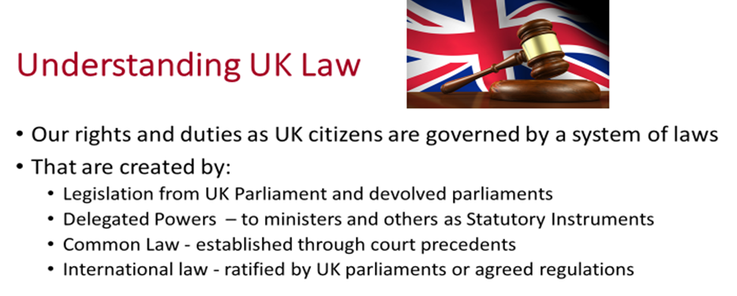
Laws define the rights and obligations of public and private organization and individuals they specify obligations to pay taxes and respect the rights of others, for example, to prevent damage to health and the environment. Most UK laws can be classified in 4 main categories:
- Primary legislation refers to statutes (Bills) passed by the Westminster parliament and the devolved Scottish Parliament, Welsh Parliament, and Northern Ireland Assembly.
- Secondary legislation refers to decisions made by Ministers or other bodies such as the London Assembly with delegated powers defined in statutory instruments, which specify their scope.
- Common law refers to the decisions made in court hearings based on precedents interpreting the rights and duties of individuals and corporations.
- International laws reflect the commonly accepted understanding of human rights, environmental safeguards, international commercial obligations and the responsibilities of governments, business and individuals for their protection.
All these forms of law may be relevant to global and local health equity as examples:
- The International Development Act introduced by the Labour Government in 2002 and subsequently amended by successive bills sets out the way UK Official Development Aid is provided to reduce poverty The Act has evolved to cover sustainable development and gender equity but not the target of 0.7% of GDP, which is described as a policy commitment see here
- The PM’s delegated power was used to merge DfID with FCO without consultation see here
- The so called “Hostile Environment “ policy was enabled by the Immigration Acts of 2014 and 2016, which delegated powers to the Home Secretary Theresa May to ensure illegal immigrants would feel unwelcome (this of course had repercussions for the Windrush immigrants) see here
- Common law has been the basis for defining human rights since the Magna Carta, consolidated in Human Rights Act of 1998 see here. The Court ruling that Shamima Begum should be allowed to return to UK shows a rift between government and judicial interpretation of human rights.
- International laws regarding human rights and their observance are discussed in the 2015 Human Rights and Democracy report see here this shows how a report from the Foreign and Commonwealth Office has guided policy decisions to address international law.
Trainers could ask their training groups to divide into 4/5 teams each to review one of these examples and report back to the full group on the key lessons they provide. Or you may simply point out that all forms of law are interrelated and depend upon how they are applied in practice.
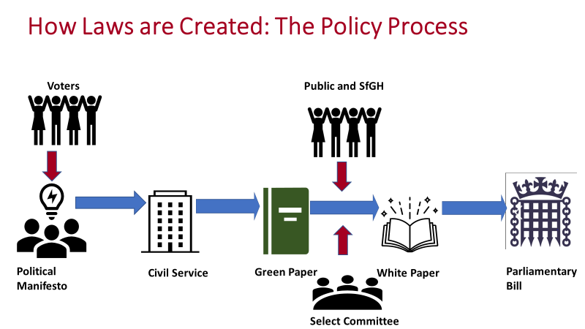
Bills which propose new laws or amendments to existing legislation can be introduced by individual members of the Commons or the House of Lords as a “private members bill” or as a government backed proposal. There is no need to base a bill on an idea or value set out in the election manifesto of a political party, nor is it necessary to consult civil service departments, issue a “Green Paper” public consultation document or clarify issues with a “White Paper”. However, these steps often provide a firmer basis for developing a Bill and ensure that support for and possible objections to the Bill are brought to light before presenting a Bill to Parliament. They also provide clear points at which the Public. Think tanks, Lobbyists and Advocates such as SfGH can contribute to the formulation of laws.
Political Manifestos have grown longer in recent years, but often with less content. The Labour Party Manifesto written in 1945 by Michael Young at the age of 29 set out the values and ideas for a new welfare state with social security and the NHS in 9 pages it is well worth reading, see here.
The Green Paper “Transforming children and young people's mental health provision” published in 2018 was a starting point for consultation and further detailed research studies and review by the Education and Health and Social Care Committees (these are select committees) which was highly critical see here.
The Current Green paper consultation “Advancing our health: prevention in the 2020s” published in 2019 provides another example of public consultation see here.
The White paper “Healthy lives, healthy people: our strategy for public health in England” published in 2010 shows the outcome of consultations which resulted in the current responsibilities of Local Authorities for public health and wellbeing see here. It is important to note that this white paper applies only to England there are alternative proposals for the other home countries, which have delegated legal authority for the provision of health and social care services.
Trainers may again choose to divide the group into teams to review and share lessons, note that it should be sufficient at this stage to review the summaries provided for each of these papers. Or you may draw the lesson that policy development is based on political principles and practical expedience.
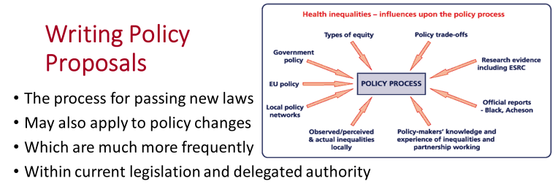
In practice most policy changes do not require new legislation but only a reinterpretation of the way current powers and resources are used. Public consultation may nevertheless follow a similar path, starting with current government policy, often referring to the manifesto. A green paper may be produced as a basis for public consultation, which may include research commissioned by ESRC, inquiries and reports from leading experts. Consultations between central government departments, with regional agencies and local authorities and with NGOs such as SfGH may follow.
The diagram shown above identifies the influences on policies aimed at addressing health inequalities in the UK in 2008, these include the Black report of 1980 and the Acheson report of 1998. In fact little was achieved in reducing inequality until the report by Sir Michael Marmot in 2010 (he is a patron of SfGH). However, his most recent report in 2019 shows that since that time progress towards reducing inequality has fallen back, perhaps due to austerity policies see here, this is discussed in Toolkit 7.
Advocacy is part of a political process. Proposals should be well evidenced, gain the support of other organisations and well presented in a brief but well written paper that reflects your values. Toolkit 12 written with Sir Muir Gray (expert on public health communications) provides guidance on this topic.
A policy proposition is not a research report but an argument for action, which could take the form:
- Summary and conclusion: A is the problem, for which we propose B solution. C,D and E are main the reasons we propose B, this will require F resources and will achieve G.
- This is the evidence for and experience of the problem A and its impact
- This is the evidence for C, D and E (separate sections giving moral and practical reasons).
- This is how it can be put it into practice (with examples of how this will be done).
- The resources required for this will be F (estimate cost and timescale)
- And this will achieve G (estimate socio-economic value if possible).
Remember short papers are more likely to be read and practical examples are more powerful than abstractions. SfGH will be only one of many organisations putting forward suggestions and NGO responses are only one of the factors influencing policy, so most advocacy fails to achieve major change, though you may have some influence and will certainly learn from the experience.
NGO proposals are more likely to be accepted if they reflect government policy, but in many cases they offer an alternative political viewpoint, more likely to gain public support but less likely to be accepted.
Trainers should ask the group to put together an outline for a report advocating policy changes to respond to Michael Marmot’s 2019 review. Perhaps write your answer as a note to Michael Marmot.
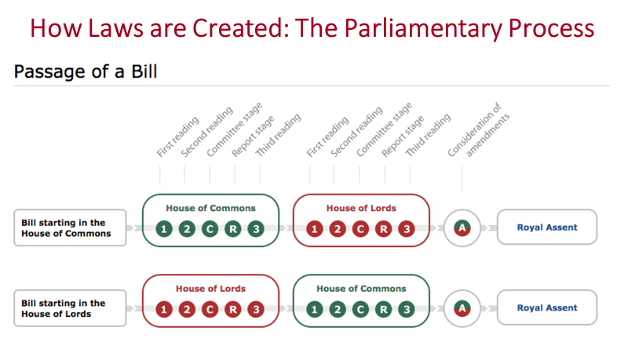
The processes of Parliament are designed to ensure that Bills are refined to meet objections where possible, agreed by majority of Members of Parliament, and are not objected to by a majority of the House of Lords. A Bill must pass through a series of stages with “Speaker Certification” at each step to decide whether the whole house or only MPs representing English Constituencies should be involved (this is the English Votes for English Laws rule applied for the first time in 2015). The main stages are:
- First Reading is a formality without debate the short title of the proposed bill is read out either in the House of Commons or the House of Lords.
- Second Reading of the Bill it is usually introduced by a Government Minister or the MP sponsoring the Bill, with a response from the official opposition spokesperson. This may lead to a debate on the principles and values underlying the Bill or it may simply be passed through.
- Committee Stage is a line by line examination of the Bill by a Public Bill Committee (PBC) formerly known as a standing committee of the Commons usually a new PBC is set up for each bill but sometimes by the whole house sitting as a committee. The committee can also ask for evidence from experts and interest groups. The House of Lords can debate wider issues at this stage and may take their time and engage all members who are interested. After review the Bill is reissued with amendments and clarifications as agreed at this stage.
- Report Stage provides another opportunity to debate the revised Bill and again suggest further amendments and additions.
- Third Reading usually follows directly after the Report Stage it is a final opportunity to debate the Bill, before final amendments and formal Royal Assent.
Trainers may wish to direct the group to the list of Bills under consideration by Parliament here (you may need to update this link). The group can search the list to find Bills relevant to SfGH advocacy and review the stage the Bills have reached and where possible a report of the current debate. This could lead to a discussion of the opportunities for SfGH to present evidence or opinions.
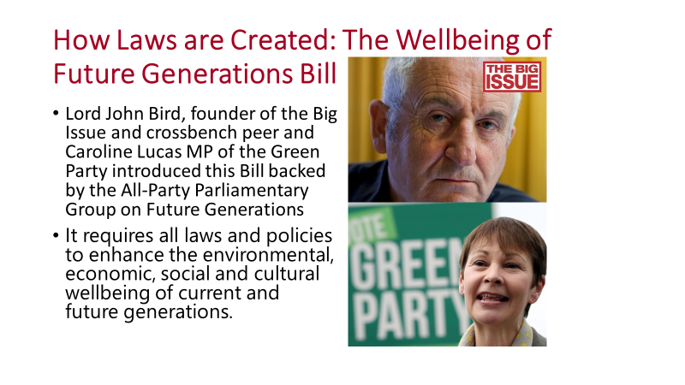
The Wellbeing of Future Generations Bill(2019-2021) is an example of the way in which legislation based on international and local policy can be brought to parliament as a Private Members Bill. The Bill is based on a similar Act passed by the Welsh Parliament in 2015. It requires all government departments and agencies to apply the UN’s 17 sustainable development goals to their policies and spending. It aims to enshrine in law the creation of an independent UK Commissioner for Future Generations and a requirement on (non-devolved) public bodies, including the UK government, to balance the needs of the present with the needs of the future in their decision making see here.
Lord John Bird who initiated the Bill and Caroline Lucas, the Green Party MP who is the co-sponsor see this as a step towards a wider social movement to dismantle poverty by laying the groundwork for a more equal society for the generations who follow. It is also hoped that other countries may adopt this approach in looking towards a sustainable, equitable future, see the Big Issue here. This requires a wider view of social progress not simply in terms of growth in GDP, but as progress towards social wellbeing.
Wellbeing is the product of the equitable political, community and cultural support that enables every individual according to their needs, to manage their physical, mental and emotional health conditions and needs, cope with normal stresses of life, find purpose and happiness, work productively and fruitfully, make a contribution to and draw support from family, community and their culture, home and natural environment. To consider how this might be assessed see here.
The impact of the 2007/9 Financial Crisis has left the country with a government debt of 80% of GDP, the current Covid-19 Pandemic will double this debt to 160% and the coming crises of Climate Change could double this debt again. Future generations will be left with unsustainable debt, public services hollowed out by austerity, very high levels of unemployment (particularly for younger people), increasing levels of inequality and existential threats to the health of our planet (see Toolkit 18). For these reasons SfGH may wish to show support for the Wellbeing of Future Generations Bill.
Trainers may wish to lead a group discussion of how SfGH can register its support for this legislation that will have a direct bearing on the health, wellbeing and equity of future generations. You could also contact the All Party Parliamentary Committee on the Wellbeing of Future Generations here.
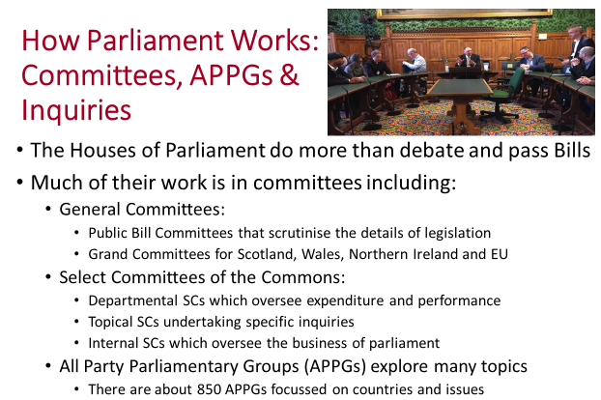
All Party Parliamentary Groups include members of all parties and both Houses and can also engage with groups and experts who are not members of either House. They can therefore be important points of contact between politicians, academics and NGOs on a wide range of issues such as Global Health, Climate Change and Lesbian Gay Bisexual and Transgender Rights. There are almost 850 APPGs so it is worth investigating to find groups interested in topics relevant to SfGH see here You will also be able to research their membership which will show those politicians with an interest in fields relevant to you.
The most relevant is the All Party Parliamentary Group on Global Health co-chaired by Lord Nigel Crisp, one of your patrons, see here Their reports all concern issues of direct relevance to SfGH:
- The UK as a global centre for health and health science – a go-to place for all aspects of health
- Triple Impact - How investing in nursing will improve health, improve gender equality and support economic growth
- The UK’s Contribution to Health Globally; Benefiting the Country and the World
- Mental Health for Sustainable Development
- Patient Empowerment: For Better Quality, More Sustainable Health Services Globally
- Improving Health at Home and Abroad: How overseas volunteering from the NHS benefits the UK and the world
- All the Talents
Trainers may ask their group to consider what contribution SfGH might make to the inquiries of APPGs and the issues they would wish to raise with them. Perhaps write a letter on this to Nigel Crisp.

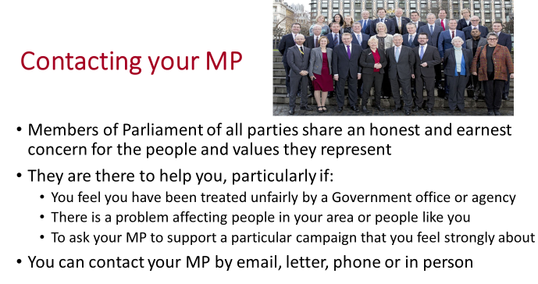
Students have a choice between voting in their family home constituency or in the constituency of their university residence (you can only vote once). In either case you should certainly Register to Vote here
This also means you can choose which of two MPs you would like to represent you, or where your vote might be most valuable. Details of how to find and make contact with your MP are available here.
You should also consider contacting members of the House of Lords, particularly members of relevant All Party Parliamentary Groups such as those concerned with Global Health and Climate Change.
When contacting your MP or a Member of the House of Lords, it is important to think through:
- The specific concerns you wish to raise and the evidence that supports this.
- If this issue has been addressed before and why it is now urgent (Google this)
- Why this might be of particular relevance to them– (look at their CV and website)
- What you hope they might do in response to your concern:
  - They might raise the issue with the responsible Minister or Department
  - They could ask a question at Question Time or submit a written question
  - They can request an Adjournment, Westminster Hall or Backbench debate see here
  - They might attempt to introduce a Private Members Bill (to raise awareness)
- How you could raise support for the steps you ask them to take
You should first contact your constituency MP, but you might then try to contact other MPs with an interest in your topic by looking through the membership of relevant committees and groups.
Addressing an MP is simple just Title (Mr Mrs Ms etc) Name, MP see here of course for Members of the House of Lords you should address them formally as Lord or Lady Name.
Trainers may wish to ask the group to prepare a letter to their MP raising an issue of concern to SfGH. You may then role play a meeting with the MP raising the questions 1-5 as above.
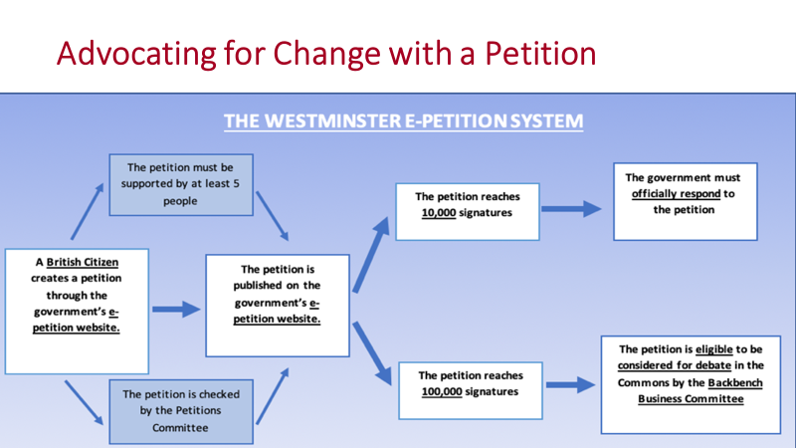

The Westminster ePetition system introduced in 2014 is an important way for SfGH to participate in the democratic process. The system allows any British Citizen to start a petition with the support of 5 others. Each petition proposal is checked (for relevance and repetition) and published on the Petition website here. Petitions which reach 10,000 signatures will receive an official response also available on the website and those which reach 100,000 are considered for debate in the House of Commons.
SfGH members should consider participating in this system by signing petitions which address issue concerning global and local health equity. SfGH membership signatures could make a significant difference to petitions and are one step in awareness raising and advocacy.
SfGH could also initiate its own petitions, in this case it might be better to adopt a coordinated approach to ensure all members of SfGH and other students are made aware of the petition and as many as possible sign it. It also provides a focal point for raising awareness amongst other students and others.
A petition proposal must deal with issues for which the UK Parliament is responsible, you should:
- State clearly what action you want to be taken,
- Explain why action should be taken and why it is important to (you, SfGH, Students, everyone)
- Provide evidence references and other background (but keep it short)
Trainers may ask teams of 3 to 5 to prepare a proposal for an ePetition asking for action on an issue of concern to SfGH meeting these guidelines. They should also plan the steps they would take to raise awareness of the petition to encourage signatures from SfGH, students and the general public.

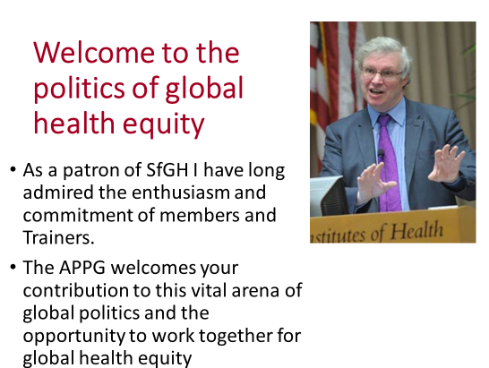

My experience of working around the globe has taught me many things about health in my own country. Three closely linked lessons that stand out clearly are:
- The importance of communities and of the social and political and environmental determinants of health. These can sometimes be obscured in our very technical and comparatively well-resourced system where we treat the patient but spend less time on understanding their environment and the causes of disease – and even less on the causes of health

- How much we can learn from people, who without our resources – and, importantly, without our vested interests and the baggage of our history – can be freer to innovate and create new solutions

- Everyone has something to teach and everyone has something to learn
As a final reflection trainers should lead a discussion of what lessons have been shared and how the group will continue to advocate for global and local health equity through parliament.

